**Craig, Edith (1869-1947)**

Edith (‘Edy’) Craig, lesbian theatre director and women’s suffrage activist, directed numerous plays and historical pageants, making significant contributions to the Little Theatre Movement in interwar Britain. After an unofficial apprenticeship as an actor and costumier with her mother Ellen Terry (1847-1928) and Henry Irving (1838-1905) at the Lyceum Theatre, she found her niche as a director. From 1908, she directed many women’s suffrage plays and several mass processions before founding the Pioneer Players theatre society in London in 1911. Her productions were always staged in a visually striking manner, with judicious use of costume and lighting.

Craig was born in Hertfordshire in 1869 to actress Ellen Terry and architect and designer Edward Godwin. Her brother Edward Gordon Craig (1872-1960) achieved international acclaim for his innovative ideas on scene design and the art of the theatre. From 1899, Craig lived with Christabel Marshall (c. 1878-1966), known as Christopher St. John, the author and music critic. In 1916, Clare Atwood (1866-1962), known as Tony, joined Craig and St. John in a lifelong ménâge à trois at 31 Bedford Street, Covent Garden and at Priest’s House near Ellen Terry’s farm at Small Hythe, Kent.

In addition to directing some of the most popular plays of the suffrage movement, including *How the Vote Was Won* (1909) and *A Pageant of Great Women* (1909), Craig staged many innovative productions for the Pioneer Players (1911-25), including works by Hrotsvit, Susan Glaspell, Anton Chekhov, Nikolai Evreinov, Paul Claudel, Gerolamo Rovetta, Herman Sudermann, José Echegeray, Torahiko Khori, and Herman Heijermanns. In the 1920s, she directed productions for the Leeds Art Theatre and the Everyman Theatre, Hampstead. She also co-edited with Christopher St. John *Ellen Terry’s Memoirs* (1932), a revised version of *The Story of My Life* (1908). From 1929, Craig and her partners endeavoured to establish Terry’s former home as a museum and a memorial to Terry.

**List of Works**

Craig, Edith. (1907) ‘Producing a Play’, *Munsey’s Magazine* (June): 311-14.

*Ellen Terry and Edith Craig Database: A Guide to the Papers from Smallhythe Place*, [www.ellenterryarchive.hull.ac.uk](http://www.ellenterryarchive.hull.ac.uk). (This database provides a descriptive catalogue of the National Trust’s Ellen Terry and Edith Craig archive of over 20,000 documents.)

**References and Further Reading**

Adlard, Eleanor. (ed.) (1949) *Edy: Recollections of Edith Craig*, London: Frederick Muller.

Auerbach, Nina. (1987) *Ellen Terry: Player in Her Time*, London: Phoenix.

Cockin, Katharine. (1998) *Edith Craig: Dramatic Lives*, London: Cassell.

Dymkowski, Christine. (1992) ‘Entertaining Ideas: Edy Craig and the Pioneer Players’, *The New Woman and Her Sisters: Feminism and Theatre 1850- 1914*, ed. Viv Gardner and Susan Rutherford, Hemel Hempstead: Harvester Wheatsheaf, 221-33.

Gandolfi, Roberta. (2003) La prima regista: Edith Craig, Rome: Bulzone Editore.

Holledge, Julie. (1981) *Innocent Flowers: Women in the Edwardian Theatre*, London: Virago.

Holroyd, Michael. (2008) A Strange Eventful History: The Dramatic Lives of Ellen Terry, Henry Irving and Their Remarkable Families, London: Chatto & Windus.

Melville, Joy. (1987) *Ellen and Edy*, London: Pandora.

**Katharine Cockin, University of Hull**

**Recommended Illustrations**

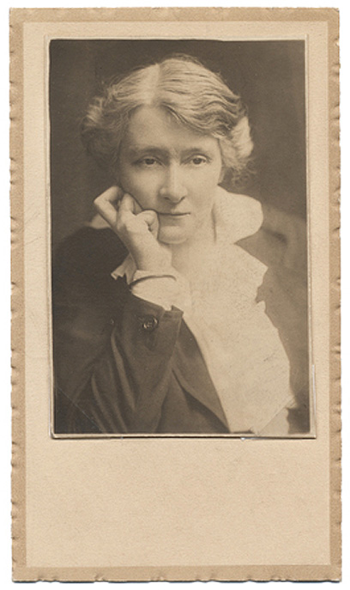

**Edith Craig (photo by E. O. Hoppé).**

[Available from the National Trust at Smallhythe Place but see below an online copy from the V&A; you will need to secure copyright permission to reproduce:

<http://www.vam.ac.uk/users/sites/default/files/67857-large_0.jpg> ]

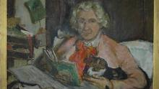

**Portrait of Edith Craig by Clare Atwood.**

[Available at Smallhythe Place, Tenterden, Kent. Copyright is held by the National Trust:<http://www.nationaltrust.org.uk/smallhythe-place/history/> ]